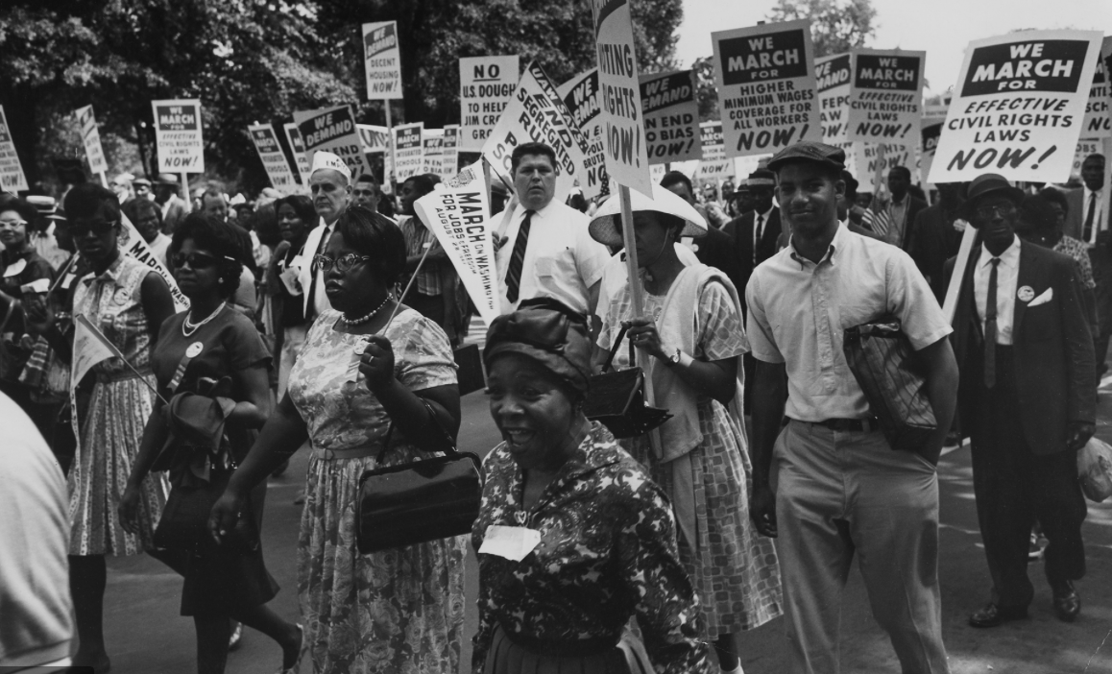

EDMA 289 Debra L. DeLaet, Professor
Summer 2021 Department of Political Science
June 7-August 20, 2021 debra.delaet@drake.edu

COURSE OVERVIEW AND DETAILS

Summary of who should take this course and why it is important:
- This course is for professionals, educators, counselors, and coaches, especially educators working in and with underrepresented school districts and communities.
- The course will serve professionals seeking to understand student activists.
- The course will enhance the school district’s curriculum.
- The course will help provide cultural awareness and understanding to be implemented in all lesson plans and within school communities.

This course is designed for educators in the K-12 educational system. The course content, described in greater detail in the next section, focuses on racial justice and human rights in the United States during the historical period from the end of World War II to the end of the Cold War. The course will focus on practical assignments that teachers, staff, coaches, and administrators can use to advance conversations about human rights and racial justice in their classrooms, schools, and communities.

This course will be held virtually. Students will primarily engage in self-guided, asynchronous learning. The course also will include several synchronous sessions to facilitate discussion of the course material and opportunities for collaboration in the design of lesson plans or other activities for fostering dialogue about racial justice and human rights in the K-12 educational system. Synchronous sessions will be held at the end of each module on Tuesdays from 9 a.m.-2 p.m. There also will be a synchronous session on Monday June 7 to go over the syllabus and course expectations. We will hold a final synchronous session on Tuesday August 17 from 9 a.m. to noon. I will develop alternative assignments for individuals who are unable to attend the synchronous sessions.

The hybrid approach to the class will maximize flexibility for students through largely self-guided learning while offering opportunities for discussion and engagement with the instructor and peers through the synchronous sessions.

Students who complete the class will earn 3 hours of graduate credit. These credit hours are based on 45 hours of direct instruction and 90 hours of work outside of class. This work is broken down as follows:
- Direct instruction:
  - Virtual lectures: 5 hours
  - Documentary Films: 10 hours
  - Synchronous class sessions: 30 hours
- Work outside of class
  - Completing assigned reading and video assignments: 50 hours
  - Completing writing, reflection, and interview assignments: 20 hours
  - Drafting lesson plans based on course material (or alternative assignments for staff, administrators, coaches, or athletic directors): 20 hours

The course ends on August 20, 2021. Grades will be posted by 5 p.m. on August 27, 2021.
COURSE RATIONALE AND CONTENT DESCRIPTION
Following the murder of George Floyd in May 2020, protests against systemic violence and racial injustices erupted across the United States. The message of the Black Lives Matter movement was amplified by these protests, and communities across the United States are increasingly engaging in conversations focused on reckoning with the long history of racial violence and injustice in the United States. These ongoing conversations have revealed important gaps in U.S. civic education. This course is designed to help educators close these gaps through an exploration of the movements for racial justice and human rights in the United States with a focus on the historical period from the end of World War II to the end of the Cold War. The course material will help educators to develop the historical knowledge that will equip them to facilitate important conversations about racial justice and human rights in their classrooms, schools, and communities.

The framework for this course integrates learning about the domestic politics of racial justice and human rights in the United States with learning about parallel global struggles for human rights, racial justice, freedom, and self-determination. The course examines the intersection between the domestic and global politics of racial justice and human rights by examining the ways in which new international human rights law shaped the civil rights movement in the United States as well as the ways in which domestic actors in the United States participated in global human rights movements connected to racial justice. The course will examine: 1) the role of the United States in shaping the development of international human rights law in ways that sought to protect its own human rights record from international scrutiny; 2) the ways in which civil rights organizations like the NAACP sought to use emerging global human rights discourse to challenge ongoing, systemic human rights deprivations in the United States; 3) the ways in which other civil rights organizations like the Civil Rights Congress appealed to the United Nations to provide redress for systemic racial violence in the United States as a form of genocide; 4) the connections between the struggle for Black freedom and equality in the United States and global movements for decolonization and self-determination; and 5) the role of African American organizations in anti-apartheid activism from the late 1960s to the late 1980s.

The course will emphasize a deep examination of these issues through careful reading of primary documents, including the Universal Declaration of Human Rights, key UN treaties adopted after WWII, petitions to the United Nations by the NAACP and the Civil Rights Congress, the report of President Truman’s Committee on Civil Rights, other primary course materials, and documentary films.
COURSE OBJECTIVES AND STANDARDS
This course aligns with the Iowa Department of Education standards.
Additional course-specific objectives include the following:
- To introduce students to the development of international human rights law by the United Nations after World War II and to examine the ways in which global human rights norms can shape domestic politics.
- To help students expand their understanding of the human rights deprivations experienced by African Americans and the ways in which Black-led organizations used human rights discourse to advocate for racial justice in the historical period from the end of World War II to the end of the Cold War.
- To help students develop an understanding of the diverse strategies and tactics used by Black-led organizations in advocating for racial justice and human rights.
- To provide students with opportunities to engage with primary source material and to develop skills in interpreting and analyzing these primary source documents.
COURSE ASSIGNMENTS
- Participation in Virtual Discussions Forums (25%): The subject matter and reading material for this course should be thought-provoking, and we will all benefit from in-depth discussion of themes and questions raised by the assigned readings and films Thus, participation in the virtual discussion forums will be a vital part of this course. At the end of each module, we will have a synchronous discussion session via Zoom in which we have a facilitated conversation about the course material. Each forum will be worth 5% of your final grade. (Students who are unable to attend a synchronous session will make alternative arrangements with the instructor.)
- Reflective Journal (25%): Students will keep a reflective journal in which they synthesize their thoughts about the course material. Students should write entries of 4-5 pages for each module of the course. At the beginning of each module, the instructor will provide discussion questions to guide your reflections. Additionally, the reflective journals should include a discussion of the main themes covered in the content. I also encourage students to share personal reactions they have to the course material and questions they have about the assigned readings and films. Students will be invited to connect course material to relevant current events. These reflective journals will provide a foundation for our virtual discussion forums. Students will submit their reflective journal entries at the end of each module of the course.
- Interview Assignment (25%): For this assignment, students are required to interview 2-3 people regarding content covered in one or more of the modules. The instructor will work with students to develop questions to facilitate these interviews. I encourage students to interview individuals who come from diverse backgrounds and are likely to have distinctive perspectives on the course material. After conducting these interviews, students will write an 4-5 page paper in which they discuss and analyze their findings. Additional guidelines and grading criteria for this assignment will be provided in class.
- The Development of Lesson Plans or Other Plans for Facilitating Conversations about Racial Justice and Human Rights in K-12 Communities (25%): As a final assignment for the course, students will choose at least one module or topic and design lesson plans for teaching the material in their own courses. Teachers will design lesson plans that effectively translate the course material for the appropriate grade level for the courses a teacher is instructing. Staff, coaches, or administrators who are taking the course will select at least one module or topic and develop appropriate plans and materials for building on course material to facilitate conversations about racial justice and human rights in the spaces in which they work—on athletic teams, among teachers or other staff and administrators, or in their communities. We will devote time during our synchronous learning sessions to sharing and providing feedback on lesson plans or other plans for facilitating community conversations about racial justice and human rights.
COURSE POLICIES AND RESOURCES
- The use of racial or misogynistic epithets or other marginalizing language in the classroom creates a hostile learning environment and will not be tolerated. Due to the nature or the course material, we will engage with texts that may incorporate references to racial or misogynistic epithets or other marginalizing language. Thus, students may encounter such language in written, oral, and visual texts assigned for the course. However, I will not utter or write out such language in class when discussing these texts, and I will not use racist, misogynistic, derogatory, or other marginalizing language inside or outside of the classroom under any circumstances, even if my point is to criticize the use of such language. In my own scholarly work, I do not write out racial or misogynistic epithets or other marginalizing language when describing the use of such language. I will not tolerate the use of racial epithets or other marginalizing language by students in the classroom.
- Cheating and plagiarism will not be tolerated. Plagiarism is the act of trying to pass off someone else's ideas, words, thoughts or inventions as one's own. Plagiarism may be intentional or unintentional, but it is a violation of academic integrity in either case. You must acknowledge your use of other's work when you quote them word for word (you must use quotation marks in the case of direct quotations), paraphrase, borrow ideas, incorporate factual information from someone else's work, or rely on another person's organization of material. You do not need to provide citations for common knowledge, but it is better to err on the side of caution if you have any doubts. If I discover a case of cheating or plagiarism, I will impose the most serious penalty allowed under university regulations and contingent on the nature of the violation. In cases of egregious plagiarism or cheating, I will give you a failing grade for the course.
- Camera Use: A substantial part of your learning in this course will depend on your active and attentive engagement in our synchronous sessions. If possible, I encourage you to turn on your camera during collaborative exchanges to help sustain a sense of community and co-presence as we learn together. However, doing so is not required; if you have reservations about turning on your video during synchronous sessions, please let me know in advance so I can plan accordingly.
- Communications and Office Hours: I will have wide availability for online office hours Monday through Friday during the course. Students should email me to set up appointments via Zoom. In general, email is the best way to reach me outside of class. I check my email frequently during normal business hours but do not check or respond to email during classes or meetings. Under normal circumstances, it is reasonable for you to expect me to respond to your email queries within 24 hours on weekdays. If you have an urgent question that you would like me to respond to promptly, you will be more likely to reach me if you send the email prior to the end of the workday at 5 p.m. Although I may try to answer emails sent on the weekend as possible or appropriate, I do not guarantee that I will respond promptly to email sent on the weekends.
- Disability Accommodations: Students with disabilities requiring reasonable academic accommodations should contact me during the first weeks of class. We can discuss your needs and work with Student Disability Services to design appropriate accommodations.
- Office for Sexual Violence Response and Healthy Relationship Promotion: Drake University is committed to the prevention of sexual assault and sexual misconduct and to support for victims when it does occur. If you are dealing with the consequences of sexual assault or misconduct, you may consult the Office for Sexual Violence Response and Healthy Relationship Promotion for assistance with your options and for potential resources for support. Due to the nature of the material for this course, some topics may serve as triggers for survivors of sexual assault. Students concerned about such triggers can see me to discuss potential accommodations as necessary.
GRADING SCALE
A+ 98-100 B+ 87-89 C+ 77-79
A 94-97 B 83-86 C 73-76
A- 90-93 B- 80-82 C- 70-72
D+ 67-69
D 63-66 F 0-59
D- 60-62
REQUIRED READINGS
Book to purchase
- Anderson, Carol. Eyes Off the Prize: The United Nations and the African American Struggle for Human Rights, 1944-1955 (Cambridge University Press, 2003). $24.53
Additional required readings available in the Course Readings folder on Blackboard.
- Civil Rights Congress, (edited by William L. Patterson), We Charge Genocide: The Historic Petition to the United Nations for Relief from a Crime of the United States Government against the Negro People, January 1, 1951.
- Dudziak, Mary L. Cold War Civil Rights: Race and the Image of American Democracy (Princeton University Press, 2000). (excerpts).
- NAACP (edited by W.E.B. DuBois), An Appeal to the World: A Statement of Denial of Human Rights to Minorities, October 23, 1947.
- Plummer, Brenda Gayle, In Search of Power: African Americans in the Era of Decolonization, 1956-1974 (Cambridge University Press, 2013). Full text available electronically from Cowles Library
- Truman Committee on Civil Rights, To Secure These Rights: the Report of President Harry S. Truman’s Committee on Civil Rights, October 1947.
- International human rights treaties, including the Universal Declaration on Human Rights, the International Covenant on Civil and Political Rights, the International Covenant on Economic, Social, and Cultural Rights, the Genocide Convention, the Conventional on the Elimination of All Forms of Racial Discrimination
- Selected children’s stories
COURSE MODULES AND SCHEDULE
Introduction to Course: We will hold a synchronous session via Zoom from 5:00-7:00 p.m. on Monday June 7 to introduce the course and to go over the syllabus and course expectations.
Module I: Universal Human Rights: Over There but not Here? (June 7-15, 2021)
This module will introduce students to the international human rights law developed by the United Nations in the aftermath of World War II. The United Nations was created after World War II as an international institution with responsibility for protecting international peace and security. In response to the revelations about the systemic violence perpetrated against the Jewish people during the Holocaust, human rights ideals also were built into the United Nations Charter, and the organization played a leading role in developing international human rights law during the postwar era. This module will introduce students to the development of human rights within the United Nations system with a focus on the UN Charter and the Universal Declaration of Human Rights. The module also will cover the racial injustices and systemic violence faced by African Americans during this period of U.S. history. The module will examine the ways in which international human rights norms shaped domestic and global critiques of the Jim Crow era in U.S. politics. The synchronous course session for Module 1 will be held on Tuesday June 15 from 9:00 a.m.-2:00 p.m.
Module II: Petitioning the World: Civil Rights or Human Rights? (June 16-29, 2021)
This module explores political debates over the universality and indivisibility of human rights within the United States and globally. The UN’s Universal Declaration of Human Rights offered a comprehensive, holistic vision of rights including civil and political rights as well as economic and social rights. Soon after the end of World War II, the Cold War emerged with ideological and geopolitical rivalry between the United States and the Soviet Union. As a result of the Cold War, global conversations about human rights increasingly focused on the division of human rights into two distinct categories: civil and political rights versus economic, social, and cultural rights. This module will look at the ways in which Cold War dynamics shaped the struggle for racial justice and human rights in the United States. Specifically, we will examine the ways in which the NAACP shifted its strategy from a broad focus on human rights to a narrower focus on civil rights in response to global and domestic political dynamics. We also will read the 1947 report of President Truman’s Committee on Civil Rights to highlight the ways in which domestic efforts to advance civil rights in the United States were constrained by global politics.
The synchronous course session for Module 2 will be held on Tuesday June 29 from 9:00 a.m- 2:00 p.m.
Module III: Never Again? American Exceptionalism at Home (June 30-July 13, 2021)
This module examines the development of the concept of genocide in international human rights law and the way the concept shaped debates over racial justice and human rights in the United States and beyond. The Genocide Convention, adopted by the international community in 1951, established genocide as a crime involving acts intended to destroy national, ethnic, racial, or religious groups. The Genocide Convention was adopted in direct response to the atrocities committed in the Holocaust. Oppressed populations across the globe appealed to the Genocide Convention to protest systemic violence and injustice perpetrated against them. In the United States, the Civil Rights Congress issued a report, We Charge Genocide, documenting systemic violence perpetrated against African Americans in the United States and unsuccessfully strived to submit this report to the United Nations in the hopes that the international community would be motivated to condemn racial injustices and systemic violence in the United States as genocide. In this module, we will read the CRC’s report and examine the political factors that prevented the report from reaching the United Nations and that impeded international action to respond to systemic racial violence in the United States.
The synchronous course session for Module 3 will be held on Tuesday July 13 from 9:00 a.m- 2:00 p.m.
Module IV: Black Power and Decolonization (July 14-July 27, 2021)
This module examines the principle of self-determination in international human rights law, a principle enshrined in both the International Covenant on Civil and Political Rights and the International Covenant on Economic, Social, and Cultural Rights. We will consider the ways in which the principle of self-determination shaped Black struggles for freedom and equality across the globe. Globally, self-determination contributed to decolonization and the emergence of newly independent countries, especially on the continent of Africa, during the period from 1956-1974. In the United States, African American activists linked the global movement for decolonization with the domestic struggles for Black power, freedom, and equality. In this module, we will look at the linked struggles against racism and colonialism by learning about the changing political dynamics in the UN General Assembly during this period as well as through an examination of the activism of the Student Nonviolent Coordinating Committee and other Black nationalist organizations in the United States.
The synchronous course session for Module 4 will be held on Tuesday July 27 from 9:00 a.m- 2:00 p.m.
Module V: Transnational Human Rights Advocacy and the Global Struggle against Apartheid (July 28-August 10, 2021)
This module will use the International Covenant on the Elimination of All Forms of Racial Discrimination as the framework for examining patters of global racism within the context of international human rights. This module will focus on a case study of anti-apartheid activism both globally and within the United States. Building on the material from Module IV, this module focuses on the transnational links among groups advocating against racial violence and injustice. The global antiapartheid movement placed domestic struggles against racial violence and inequality in the broader context of global racism. In the United States, African American organizations mobilized against apartheid in South Africa. Simultaneously, anti-apartheid activists in the United States framed U.S. racial violence and inequality as existing within a system of global racism and as part of the struggle for global human rights. In this module, we will examine global and domestic antiapartheid activism by learning about the work of the UN General Assembly in mobilizing global public opinion against apartheid and the parallel antiapartheid activism of a range of organizations in the United States, including the Congress of African people, the Pan-African Liberation Committee, and the African Liberation Support Committee.
The synchronous course session for Module 5 will be held on Tuesday August 10 from 9:00 a.m- 2:00 p.m.
Conclusions to Course: We will hold our final synchronous session via Zoom from 9:00 a.m.-noon on Tuesday August 17, 2021. We will discuss primary takeaways from the course. Students will present their lesson plans or other plans for building on the learning from this course to facilitate conversations on racial justice and human rights in their schools and/ or communities. Participants will provide constructive feedback on their colleagues’ presentations. Between August 17 and August 20, students will be able to revise their plans. Students will submit their final work by 5 p.m. on Friday August 20.

